**Dr.M.G.R GOVERNMENT ARTS & SCIENCE COLLEGE FOR WOMEN**

**PROPERTY MANAGEMENT APPLICATION USING SALESFORCE**

**INTRODUCTION**

* 1. **Overview**

Salesforce is the world’s leading CRM platform that caters to the needs of over 150,000 clients of all business domains and sizes. It offers 20 off-the-shelf CRM suites called “Clouds” that focus on various needs and industries. Among the most popular ones are Sales Cloud, Service Cloud, and Marketing Cloud.

As a CRM industry leader, Salesforce tries to fulfill the basic demands for the software of any business. And over 2,000 Salesforce consulting partners are ready to tweak the system to every tiny business request.

And even if Salesforce doesn’t offer CRM packages specifically for property management companies, there are Salesforce consulting and AppExchange app development partners like Ascendix that can customize and configure the system to match any tiny requirement.

Moreover, if you want to purchase an out-of-the-box CRM system with the most common feature set for property managers, developers, and investors, Salesforce’s app marketplace – AppExchange – already has 400+ apps and solutions designed for this.

* 1. **purpose**

We are a Salesforce consulting partner with a 21-year track record of successfully completed projects of Salesforce implementation, migration, configuration, and customization for different real estate companies.

We aim to deliver superior and top-notch quality services to clients all around the world. Instead of focusing just on making money from our clients, we dedicate our efforts to delivering them perfection and maximum satisfaction.

Our team works sincerely and aggressively to implement a customer-centric practical philosophy in our services and CRM products.

Besides that, we are a certified AppExchange app development partner that has built 17 own software products, among which our flagship products for commercial real estate pros: AscendixRE, Ascendix Search, Composer, and Marketspace.

**Problem Definition & Design Thinking**

**2.1** **Empathy Map**

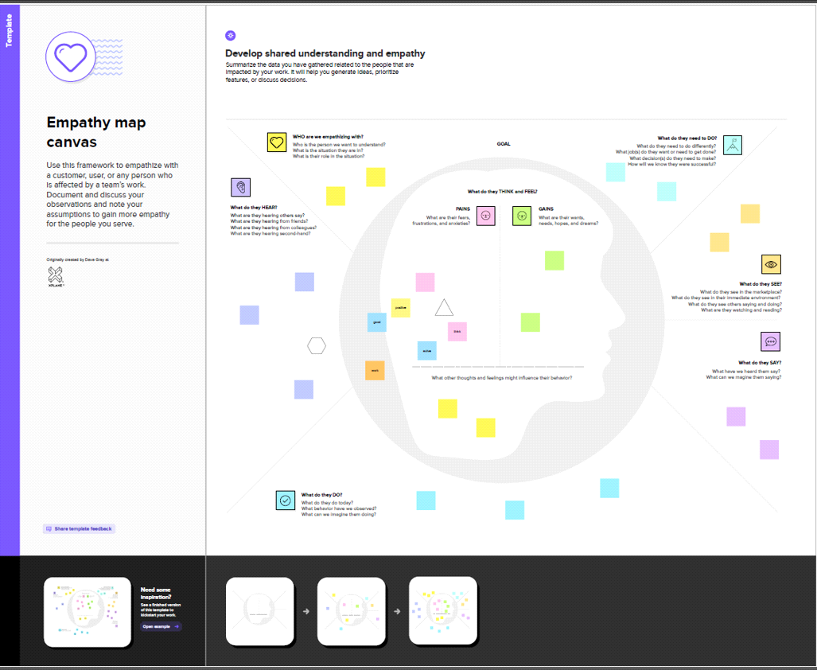

**2.2 Ideation & Brainstorming Map**

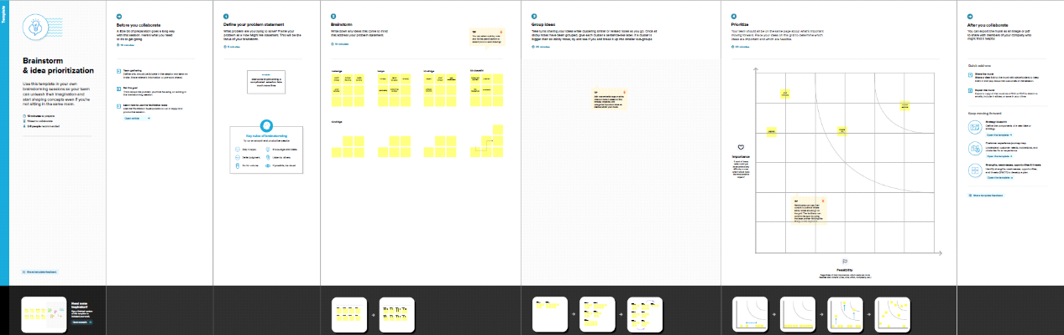

**3. RESULT**

**3.1 Data Model**

|  |  |
| --- | --- |
| **Object name** | **Fields in the object** |
| **Obj1** | |  |  | | --- | --- | | **Field label** | **Data type** | | **Discount** | **Number** | | **Rent city** | **Picklist** | |
| **Obj2** | |  |  | | --- | --- | | **Field label** | **Data type** | | **Loan Amount** | **Currency** | | **Lead** | **Number** | |

**3**.**2 Activity & Screenshot**



**4** **Trailhead Profile public URL**

Team Lead – https://trailblazer.me/id/mahav45

Team Member 1 - https://trailblazer.me/id/laliv2

Team Member 2 -https://trailblazer.me/id/lavaa12

Team Member 3 -https://trailblazer.me/id/moni183

**5 ADVANTAGES & DISADVANTAGES.**

**Advantages**

* Leverage real-time reports and dashboards.
* Streamline lead, opportunity, and contact management.
* Simplify document management and data sharing.
* Enhance communication and collaboration tools.

**Disadvantages**

* Expensive.
* You have to pay for add-ons to get the most out of the software.
* Configuration and setup is complex and time-consuming.
* Cluttered interface makes navigation and simple tasks unnecessarily complex.
* The learning curve never seems to end.
* Customer support has a poor reputation.

**6 APPLICATIONS**

**ADVANTAGES**

o Provides a management model. The application takes into consideration the best management practices, which allows it to consolidate the way in which its team of collaborators works and carry out a more complete and detailed management.

o Everything in one single system. Integrates in one single application the modules that usually exist separately. The client accesses all the modules that it needs to manage the real estate business in an integral manner.

o Maximum availability and security. The application is built and operates with the best technology in the world: Salesforce.com

o Permanent access from anywhere. Access to the application at anytime from anywhere and with any device connected to Internet. (Smartphone, Tablet, PC).

o Your needs are personalized. You can create new fields and eliminate the ones unused. You can create new sections and reorder the fields. o Adjust language. All names and field labels can be changed to allow for the personalization of each company or country.

o Allows the creation of any report. It can create and modify any report, include filters, change columns, order in any criterion and go to Excel.

o Allows to send emails. It creates and sends emails from the application that are received as if they had been sent from their own electronic mail source.

o Allows to create recurring emails in template mode, which allows to send email created automatically.

o Generation of alarms. Allows the configuration of workflow that generates alarms for incoming email or reminders of certain dates such as expirations or renewals.

o User profiles. Users may access information according to the profiles that they have assigned and which are defined by the Administrator.

o Information backup. Automatic programmed backup so that the client may have a copy of all the information registered in the system.

o Chatter. Internal chat allows instant communication among users and mailing attachments.

**DISADVANTAGES**

o Value added to the business. - Duplicate the number of sales, leases and administration, thus duplicating the income. - Reduce by half the time needed for real estate management and thus the costs - Improve sales rate and successful lease contracts due to better client management. - Reduce administration problems with timely attention due to improved information. - Improve level of service, tenants, owners and internal clients. - Reduce late payments through improved service and control.

o Improvement of decision making and control. - Improve decision making capacity with better information through personalized reports. - Availability of information in real time on the entire team of collaborators and the business.

o Implementation and support. - Immediate initiation of operation. - Permanent support.

o Adaptability to every type of business. - The application adapts to every type of business through the capacity to create new fields, eliminate the ones unused and create email templates. - You can test the application and adjust it to your business before buying it.

o Information security. - Increase the level of security of the information in the Salesforce.com Cloud with maximum levels of security worldwide, thus avoiding loss of information, and immediate access from anywhere.

**7.CONCLUSION**

**In conclusion, Property Management System (PMS) software is very crucial for all the Hotels. Especially Opera PMS constitutes the most appropriate PMS software for Hilton Athens. It is user friendly, connects with Central Reservation System (CRS), Point of Sale (POS) etc. and provides all the tools the hotel needs in order to operate effectively. The disadvantages of the Opera PMS can be improved easily and as it was mentioned before a recommendation is the upgrade of Opera V5 to Opera 9.**

**8.FUTURE SCOPE**

Property managers' work became very appreciated when the world started to suffer a pandemic. Property managers were underrated until their services were imperative to keep rental properties above water.

The twenty-twenties have assured a new era of property management, and here's what we see now and predict more of in the future of property management.